|  |  |  |
| --- | --- | --- |
| CHAI Research Interface | 2014 | |
| The Goal of this document is to provide you a guide, with which you may add and edit items in the CHAI HIV research data interface. | | Revision: 1.5 |

Help Doc.

# General Notes:

* Save/apply buttons will save the data and return you to your current location
* Submit buttons save the data and send you to the list of the items you were editing.

# Admin

You can log in to the admin from two directions. From the upper right hand gear icons or type the url address after the root of ‘/admin’.

**Add/Edit user:**

1. Under the menu item “Users” click on Users list
2. Click “New User” at the top
3. Fill in the form
4. Click save

**Note:** the User Network ID for CHAI is your email. IE: username@clintonhealthaccess.org

**Add/Edit Privileges:**

1. Under the menu item “Groups” click on Users list
2. Choose the “Privileges” tab
3. Click “New Privileges” at the top
4. Fill in the form
5. Click save

**Apply Privileges:**

1. Under the menu item “Groups” click on Users list
2. Choose the group to edit under the “Groups” tab
3. Move to the “Privileges” tab and check which privileges apply
4. Click save

**Add/Edit Groups:**

1. Under the menu item “Groups” click on Users list
2. Choose the group to edit under the “Groups” tab
3. Fill in the form
4. Click save

**Add/Edit Taxonomy:**

1. Under the menu item “Sites” click on Taxonomies
2. Choose the Taxonomy type from the left navigation bar
3. Click the + New Button
4. Fill in the form
5. Click save

**Note:** Url and Content are optional and used in templates only. Skip this.

**Restore a Deleted record/permanently remove:**

1. Click the Trash bin link in the menu to the far right.
2. Choose the items to restore or delete in mass.

# Frontend

## Clinical Trials:

This module of the CHAI database is designed to capture information related to clinical trials being performed on ARVs.  Information needed in this module will come from many sources including regulatory documents, innovator publications, [*www.clinicaltrials.gov*](http://www.clinicaltrials.gov) , and other associated publications or presentations at conferences.  For drug products under development and therefore with clinical trials in the early stages (Phase 1, 2, and potentially 3), information may be more difficult to find as it might not yet be publicly available with the exception of the information publicly available on [*www.clinicaltrials.gov*](http://www.clinicaltrials.gov/)

**Edit something:**

1. Fill the form as fully as possible

## Regimens:

**Edit something:**

1. Fill the form as fully as possible

## Drug Products:

This module of the CHAI database is designed to capture information on drug products used as part of ARV therapy.  Information needed in this module will largely come from regulatory documents associated with the approval of the drug product for marketing and particularly from the drug product approved package insert.  For drug products under development and therefore in the IND stage, information may be more difficult to find as it might not yet be publicly available.

**Edit something:**

1. Fill the form as fully as possible

## Drug Substances:

This module of the CHAI database is designed to capture chemistry-related information on the active pharmaceutical ingredient (API) in drug products. Information needed in this module will largely come from regulatory documents associated with the approval of the drug product for marketing and particularly from the chemistry review section of the dossier. For drug substances under development and therefore in the IND stage, information may be more difficult to find as it might not yet be publicly available. Information may also come from publications on the API in chemistry and related journals and presentations.

**Edit something:**

1. Fill the form as fully as possible

## References:

**Edit something:**

1. Fill the form as fully as possible

## Trash bin:

**Note:** you may only do a soft deletion of from the system of the record. What this means is that if you don’t have admin rights on the system you will not be able to clear items from the trash bin.

## Reports:

**Save a report:**

1. Run a report. Select your values and click run.
2. Once you have run a report, just click save at the bottom and you’ll be able to run it again.

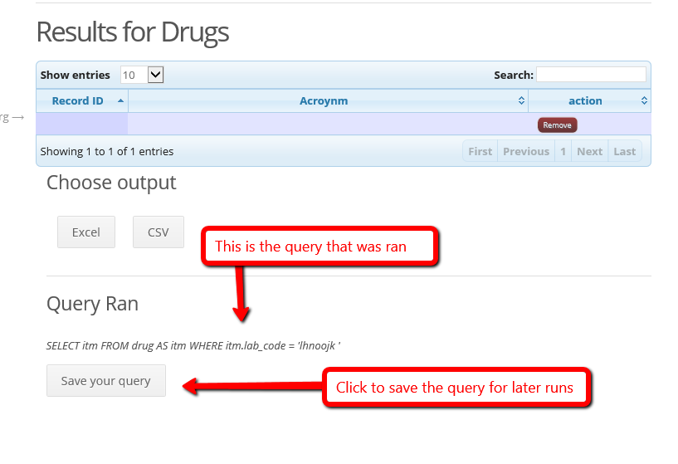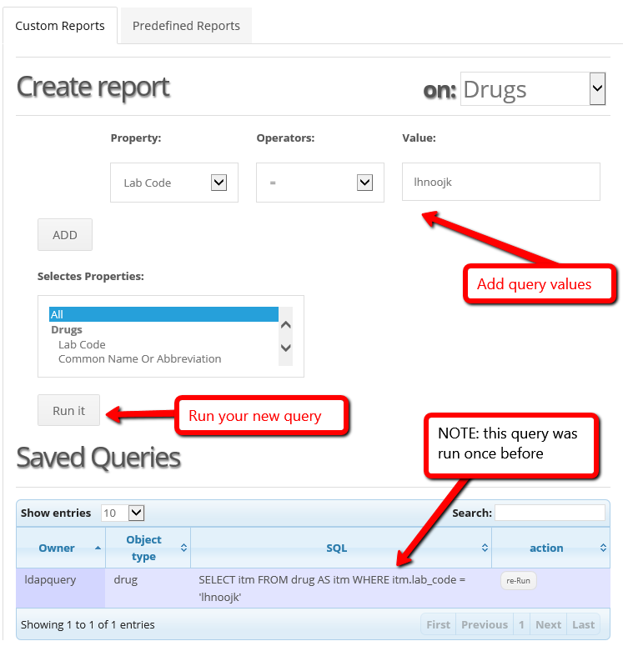

Appendix A – (AE) list

# Adverse Events

**Abnormal Dreams** -- Unusual or atypical Dreams

Acute Renal Insufficency -- Aka Acute Renal Failure (ARF) or Acute Renal Injury (ARI)- Means a rapidly progress loss of renal function, characterized by decrease urine production, fluid and elecrolyte imbalance, Increase in serum creatinine level

**Alopecia** -- Loss of Hair

**Anemia** -- Decrease of hemoglobin in blood

**Anthraigias** -- Joint Pain

**Anxiety** -- An abnormal and overwhelming sence of apprehension of fear often marked by phsiological signs (as sweating, tension, increase pulse), by doubt concerning reality and nature of the threat, and by self-doubt about one's capacity to cope with it.

**Asthenia** -- Weakness, due to lack or loss of strength

**Blood Clotting** -- Process which involves shedding of blood and interaction of thrombin to form insoluble fibrin network

**Cholangitis** -- Inflamation of bile duct or entire biliary tree

**Cholencystitis** -- Inflammation of gal bladder

**Cholelithiasis** -- Presence of a stone in the common bile duct

**Chronic Renal Insufficency** -- Aka Chronic Renal Failure, or Chronic Renal Disease, which is a progressive loss of renal function over period of months or years. Often present with high levels of creatinine which indicate low glomerular filtration rate.

**Coughing** -- To expel air from the lungs suddenly

**Depression** -- State of feeliing sad, marked by inactivity, difficulty with thinking, increase or decrease of appetite, feelings of dejection, hopelessness, attempt ot commit suicide

**Diabetes Mellirtus** -- Deficency of insulin and characterized by chronic increase in blood glucose and other long term complications

**Diarrhea** -- Abnormally frequent intestinal evacuations with more or less fluid stools

**Dizziness** -- Sensation of unsteadiness accompanied by feeling of movement within the head

**Dyslipidemia** -- Elevation of total cholerserol, LDL and triglyceride levels

**Emesis** -- Vomiting

**Erythema** -- Redness

**Fatigue** -- Weariness or exhaustion

**Fever** -- Rise of body temperature above the normal

**Flank Pain** -- Pain in one side of the abdominal area

**Flatulence** -- Presence of excessive amount o fgas in stomache and intestines

**G.I. Intolerance** -- Upset Stomach

**Headache** -- Pain in the head

**Hepatic Flares** -- Sudden increase in liver enzymes

**Hepatomegaly** -- Liver enlargement

**Hyperbilirubenimia** -- Excess bilirubin in the blood

**Hypercholesterolemia** -- Excess cholseterol in the blood

**Hyperpigmentation** -- excess pigment in bodily part or tissue

**Hypertension** -- High blood pressure

**Hypertriglyceridemia** -- excess amount of triglyceriedes in the blood

**Hyperuricemia** -- Excess uric acid in the blood

**Hypohosphatemia** -- Deficency of phosphates in the blood

I**mpared Concentration** -- Difficulty in maintaining a fixed, close, undivided attention

**Ingrown Nails** -- When the edge of the anil grows down and into the skin o fthe toes- may present as pai, redness, swelling around the nail

**Insomnia** -- Trouble sleeping

**Insulin resistance** -- Reduced sensitivity to insulin by body's insulin-dependence processes that result in lowered activity or increase in insulin production, often occurs in absence of diabetes

**Jaundice** -- Yellowish pigment of the skin, tissues and certain body fluids caused by deposition of bile pigments

**Lethargy** -- Drowsiness, state of being lazy, sluggish or indifferent

**Lipodystrophy** -- Loss of fat from or deposition of fat from tissue

**Lipohypertophy** -- Lump under skin caused by accumulation of extra fat

**Loss of appetite** -- Loss fo desire to eat food

**Malaise** -- Feeling of debility or lack of health

**Male Gynecomastia** -- Excessive development of breast in male

**Metabolic Syndrome** -- Syndrome marked by presnece of usually 3+ group of factors: High blood pressure, abdomina obesity, high triglyceride leevels, low HDL levels, high fasting blood sugar, which are linked to an increased risk of cardiovascular disease and type 2 diabetes, and Alzheimer's disease

**Myalgia** -- Pain in one or more muscle

**Myopathy** -- Disorder of muscle tissue or muscles

**Nausea** -- A sensation of unease and discomfort in the upper stomach with an invoulentary urge to vomit

**Neurological Toxicities** -- Damage to the neervous system presenting symptoms from limb weakness, numbness, loss of memory/vision

**Nightmares** -- Distrurbing dreams

**Osteopenia** -- Reduced bone mineral density

**Pain (Back, Leg, Neck)** -- State of physical, emotional, or mental lack of well-being or pysical, emotiona, or mental uneasiness that ranges from mild discomfort or dull distress to acute often unbearable agony, may be generalized or localized

**Pneumonia** -- Inflammation and consolidation of lung tissue followed by resolution, accompanied by fever, chills, cough, and difficulty in breathing

**Prolong PR Interval** -- Increased PR interval in heart rhythm, may increase risk of atrial fibrillation

**Pruritus** -- Localized or generalized itching

**Sneezing** -- A sudden violent spasmodic audible expiration of breath through the nose and mouth especially as a reflex act following irritation of the nasal mucous membrane

**Somnolence** -- Quality or state of being drowsy

**Suicidal ideation** -- Increase inclination to cause suicide

**Taste Perversion** -- Distroted sence of taste

**Torsades de pointes** -- Heart arrhythmia which is characterized by fluctuation of QRS complexes

**Vomiting** -- Act of disgorging contents of stomach through mouth

**Weight change** –

# Severe Adverse Events

**Birth Defects** –

**Death** --

**Fanconi syndrome** -- Disorder of proximal renal tubules in which certain substances (Amino acids, glucose, uric acid, phosphates) normally absorbed into the blood stream by kidneys are released in the urine instead

**Hematuria** -- Presence of blood or red blood cells in urine

**Hepatic toxicity** -- Drug-induced liver damage which manifest as abnormal liver enzyme testes

**Hypersensitivey syndrom**e -- Severe, idiosyncratic multi-system reaction defined by fever, rahs and internal organ involvement which may ocur 1-8 weeks after exposure to drugs

**Immune reconstitution syndrome** -- Collection of inflammatory disorders associated with paradoxical worsening of preexisting infectious processes following HAART initation

**Intracranial Hemorrhage** -- Bleeding within cranial vault, includes cerebral hemorrhage and subarachnoid hemorrhage

**Lactic Acidosis** -- Type of metabolic acidosis caused by accumulation of lactic acid in bloodstreem

**Lipoatropy** -- Loss of subcutaneous fat

**Liver failure** -- Condition in which the liver fails to fulfill it's function or is unable to meet the demands made on it. Anorexia, fatigue, and weakness are common symptoms of liver cell failure, whereas jaundice in indicates a biliary obstruction and fever may accompany viral or alcoholic liver diseases.

**Mitochondrial Infraction** -- Heart attack, often use to blood clots that block flow of blood through coronary artery

**Nephrolithiasis** -- Kidney stones

**Nephrotixicity** -- Drug toxicity in kidney

**Neural Tube Defects** -- Major birth defect present as abnormal of the neural tube which gives rise to the central nervous system

**Neurologic toxicities** -- Drug induced toxicities in the nervous system

**Neuromuscular Weakness** -- Generalize weakness that affects the muscles which controll respiration

**Neutropenia** -- Abnormally low count of neutrophils, which is a type of white blood cells

**Pancreatitis** -- Inflimation of the pancreas

**Peripheral Neuropathy** -- Numbness and pain in hands and feet, can also be described as a tingling or burning senstaion

**Prematurity** --

**QT Interval Prologation** -- Heart rhythm disorder in which QT interval is longer than normal, which can cause fast and chaotic heart beats, may trigger sudden fainting spell or seizure

**Rash** -- Group ofspots or red, inflamed skin that is usually a symptom of an underlying condition or disorder

**Rhabdomyolsis** -- Severe muscle pain that is caused by breakdwon of muscle cells

**Seizure** -- Uncontrolled electrical activity in teh brain, which may producte a physical covulsion, monor physical signs, thought distrubances, or a combination of symptoms

**Steatosis** -- Fatty liver, collection of excessive amounts of triglycerides and toher fats inside liver cells

**Stevens-Johnsons Syndrome** -- Rare and serious disorder in which skin and mucous membranes react severely, begins with flu-like symptoms, followed by painful red or purplish rash that spreads and blisters, eventually causing top layer of skin to die and shed, often presnt as medical emergency and require hospitalization

**Stroke** -- Aka cerebral vasculr accident (CVA), rapid loss of brain function due to t disturbance in blood supply to the brain may do to lack of blood flow caused by blockage

**Increased liver enzymes** --